Ideation Phase
Brainstorming Template

Date | 10-02-2026
Team ID | LTVIP2026TMIDS65437
Project Name | Flavour Fusion: - Ai-Driven Recipe Blogging
Maximum Marks | 4 Marks

Brainstorm & Idea Prioritization Template:
Brainstorming provides a free and open environment that encourages everyone within a team to participate in the creative thinking process that leads to problem solving. Prioritizing volume over value, out-of-the-box ideas are welcome and built upon, and all participants are encouraged to collaborate, helping each other develop a rich number of creative solutions.
Use this template in your own brainstorming sessions so your team can unleash their imagination and start shaping concepts even if you're not sitting in the same room.
Reference: https://www.mural.co/templates/brainstorm-and-idea-prioritization
Step-1: Team Gathering, Collaboration and Select the Problem Statement
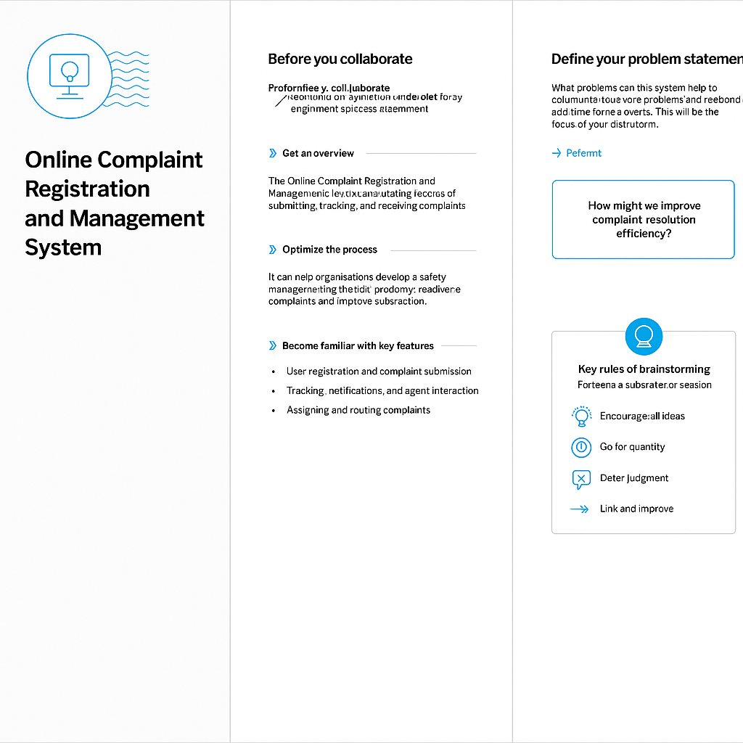
Step-2: Brainstorm, Idea Listing and Grouping



Step-3: Idea Prioritization: -
Rules of Brainstorming: -
Defer Judgment: Do not criticize or evaluate flavor ideas during the initial brainstorming phase. Even "bad" ideas can trigger brilliant, workable combinations.
Encourage Wild Ideas: Aim for unconventional, "crazy" combinations (e.g., pairing miso with chocolate). AI excels at identifying non-obvious, data-driven connections (such as aroma molecule overlaps) that human chefs might overook.
Go for Quantity: Generate as many ideas as possible. The goal is to have a high volume of potential combinations to sift through later.
Build on Ideas of others: Use "Yes, and..." rather than "No, but...". Use the AI to expand on an initial, rough idea (e.g., "What if we add basil to that mango.
There are some other rules are found for brainstorming as shown in below figure: -
- Stay focused on the topic
- Be visual

